Exercise 1. Given the network below, calculate marginal and conditional probabilities Pr(¬p3), Pr(p2|¬p3), Pr(p1|p2, ¬p3) and Pr(p1|¬p3, p4). Apply the method of inference by enumeration.

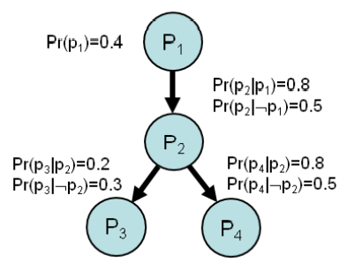

Exercise 2. For the same network calculate the same marginal and conditional probabilities again. Employ the properties of directed graphical model to manually simplify inference by enumeration carried out in the previous exercise.